Quy Pham
G00459909
ECE 201 – LAB 4
Programming in MATLAB
Feb 24, 2008
while(true) % keep looping until user choose to end program
%--------------------------------------------
% Question 1
%--------------------------------------------
while(true)
display('Choose from the following menu:');
display('---Enter complex number in polar form (1)');
display('---Enter complex number in rectangular form (2)');
display('---End program(0)');
res = input('Type in your choice here:');
if(res == 0)||(res == 1)||(res == 2)
break % user entered a correct choice(between 0-2), jump out of while loop
else
% user entered a wrong choice, display error and display menu
% option again
display('Your input has to be between 0-2');
end
end

%--------------------------------------------
% Question 2
%--------------------------------------------
% user wanted to quit, end the program
if(res == 0)
return; % exit

%--------------------------------------------
% Question 3
%--------------------------------------------
% user wanted to enter a complex number. Interprete his choice...
elseif(res == 1) % complex number in polar form
polar_res = 0;
while((polar_res ~= 1)&&(polar_res ~= 2)) % keep looping until user enters a right input
disp('Enter phase in:');
disp('--Degrees(1)');
disp('--Radian(2)');
polar_res = input('Choice (1 or 2): ');
if(polar_res ~= 1)&&(polar_res ~= 2) % the input is not 1 or 2, ask user enter his choice again
disp('Your input need to be only 1 or 2. Try again...');
end
end

disp('First complex number c1');
phase = input('Enter phase: ');
if(polar_res == 1) % phase in degree
phase = phase*pi/180; % convert to radian
else % phase in radian
% do nothing
end
m = -1;
while(m < 0)
m = input('Enter the magnitude (positive number): ');
end
x1 = m*cos(phase);
y1 = m*sin(phase);
c1 = x1 + i*y1;
disp(['C1 = ',num2str(x1),' + j',num2str(y1)]);

disp('Second complex number c2');
c2 = c1;
while(c1 == c2)
phase = input('Enter phase: ');
if(polar_res == 1) % phase in degree
phase = phase*pi/180; % convert to radian
else % phase in radian
% do nothing
end
m = -1;
while(m < 0) % magnitude must be positive
m = input('Enter the magnitude (positive number): ');
end
x2 = m*cos(phase);
y2 = m*sin(phase);
c2 = x2 + i*y2;
if(c2 == c1)
disp('C2 = C1. Please enter a different number');
end
end
disp(['C2 = ',num2str(x2),' + j',num2str(y2)]);
elseif(res == 2) % complex number in rectangular form
disp('First complex number C1 = x + jy');
x1 = input('Enter the real part x = ');
y1 = input('Enter the imaginary part y = ');
c1 = x1 + i*y1;
disp(['C1 = ',num2str(x1),' + j',num2str(y1)]);
disp('Second complex number C2 = x + jy');
c2 = c1;
while(c2 == c1) % c2 and c1 have to be dif. otherwise keep prompting for dif input
x2 = input('Enter the real part x = ');
y2 = input('Enter the imaginary part y = ');
c2 = x2 + i*y2;
if(c2 == c1)
disp('C2 = C1. Please enter a different number');
end
end
disp(['C2 = ',num2str(x2),' + j',num2str(y2)]);
disp('How do you want to show the phase in polar form ?');
disp('--Degrees (1)');
disp('--Radians (2)');
rect_res = 0;
while(rect_res ~= 1)&&(rect_res ~= 2)
rect_res = input('Choice(1,2)?: ');
end
% calculate the magnitudes
m1 = sqrt(x1*x1+y1*y1);
m2 = sqrt(x2*x2+y2*y2);
% and the phases
phase1 = atan(y1/x1);
phase2 = atan(y2/x2);
if(rect_res == 1) % display phase in degree
phase1 = phase1*180/pi; % convert radian to degree
phase2 = phase2*180/pi;
disp(['C1 has magnitude ',num2str(m1),' and phase ',num2str(phase1),' degree.']);
disp(['C2 has magnitude ',num2str(m2),' and phase ',num2str(phase2),' degree.']);
else % display phase in radian
disp(['C1 has magnitude ',num2str(m1),' and phase ',num2str(phase1),' radian.']);
disp(['C2 has magnitude ',num2str(m2),' and phase ',num2str(phase2),' radian.']);
end
end
%--------------------------------------------
% Question 4
%--------------------------------------------
c3 = c1 + c2;
%--------------------------------------------
% Question 5
%--------------------------------------------
figure(1);
hold on; % plot all 3 complex numbers on the same plot
t = 0:0.01:1;
plot(real(c1)*t,imag(c1)*t,'ro'); % red circle
plot(real(c2)*t,imag(c2)*t,'bs'); % blue square
plot(real(c3)*t,imag(c3)*t,'kd'); % black diamon
xlabel('Real');
ylabel('Imaginary');
title('Complex Numbers');
hold off;
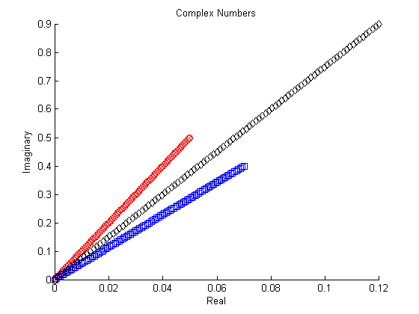
%--------------------------------------------
% Question 6
%--------------------------------------------
nn = 0:1:20;
y = c3.^nn;
figure(2);
plot(y);
xlabel('Real');
ylabel('Imaginary');
grid;
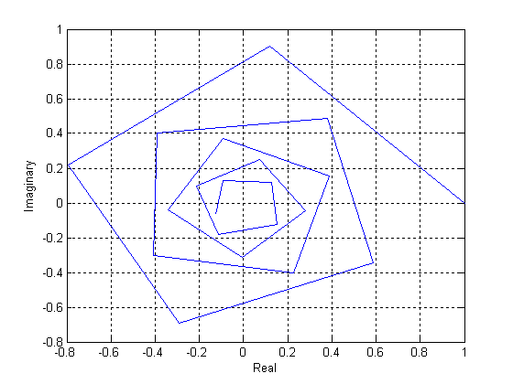
% The result is a clock-wise whirl figure which is formed by vectors. The end of the
% previous vector is the start of the next one and the next one , and so on out of the center.
% The turning angles are the same.
% The vector's size keeps increasing after another.

%--------------------------------------------
% Question 7
%--------------------------------------------
end

%-----------------------------
% Diary file
%-----------------------------
lab4
Choose from the following menu:
---Enter complex number in polar form (1)
---Enter complex number in rectangular form (2)
---End program(0)
Type in your choice here:2
First complex number C1 = x + jy
Enter the real part x = 0.05
Enter the imaginary part y = 0.5
C1 = 0.05 + j0.5
Second complex number C2 = x + jy
Enter the real part x = 0.07
Enter the imaginary part y = 0.4
C2 = 0.07 + j0.4
How do you want to show the phase in polar form ?
--Degrees (1)
--Radians (2)
Choice(1,2)?: 1
C1 has magnitude 0.50249 and phase 84.2894 degree.
C2 has magnitude 0.40608 and phase 80.0738 degree.
Choose from the following menu:
---Enter complex number in polar form (1)
---Enter complex number in rectangular form (2)
---End program(0)
Type in your choice here:0
diary off

